Peer Evaluation for Lab 6 – Chapter 13
Your name: (Your lab is the one being evaluated) | Will Schultz
Name(s) of peer evaluator(s)
Date: | 6/1/2018

Instructions
You should have already completed Lab 6. After you and a peer have evaluated your work, you will submit this evaluation along with screen shots and source code indicated in moodle. You may make corrections to your work as a result of the evaluation.
In Class Exercises – CustomeList Class – Exercise 13.1 (NOT THE UI EXERCISES)
Completed CustomerList Class?  - Created a class diagram in visual studio? Screen shot included?  - Instance variables are camelCase and private?  - Property/Method names are TitleCase? Properties/Methods are public?  - Implements all properties/methods in the specification in the chart on page 419?  - Implements + and - operators?  - Implements delegate named ChangeHandler and Changed event?  - Implements any other methods/operators for extra credit? What are they?  - Completed Customer Tests? Tests all properties and methods in the class? Tests + and – operators? DOESN’T NEED TO TEST the delegate and event. Screen shot is included?  - Source code includes CustomerList class as well as test program? | Yes  Yes  Yes  Yes  Yes  No  No  Yes  Yes
One thing that you learned from writing and testing the class:
I learned how to create a class list. I also learned about overloading operators, relational operators, and some list methods.

Something that you’d like to continue working on:

Time you spent completing and testing the class:

Class diagram, screen shot of test running, test code, class code
CustomerList Class
Property | Method | Indexer
Count | Add(X2) | Int[i]
 | Remove | String[email]
 | Save | //string[lastName]
 | Fill
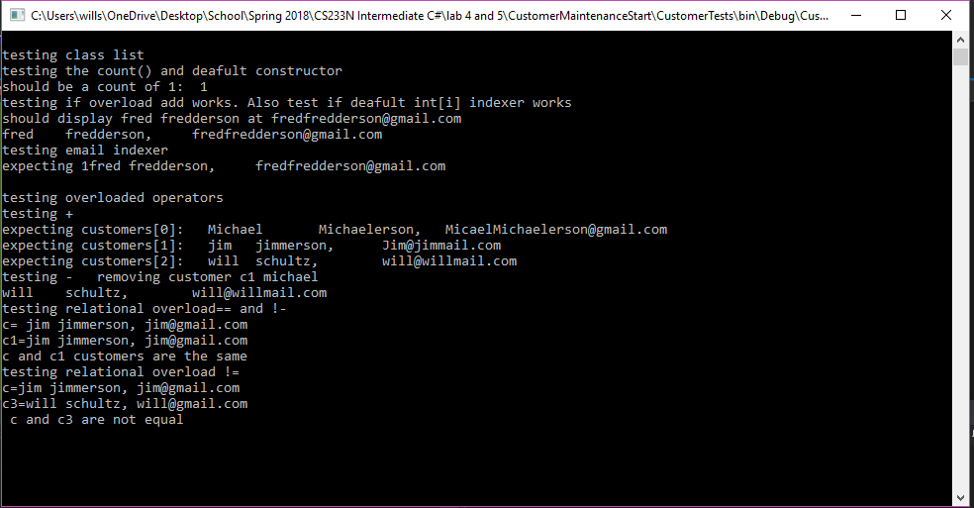

namespace CustomerMaintenanceClasses
{
public class CustomerList
{
private List<Customer> customers;

public CustomerList()
{
customers = new List<Customer>();
}
public int Count()
{
return customers.Count;
}
public void Add(Customer customer)
{
customers.Add(customer);
}
public void Add(string firstName, string lastName,string email)
{
Customer c = new Customer(firstName, lastName, email);
customers.Add(c);
}
public void Remove(Customer customer)
{
customers.Remove(customer);
}
public void Fill()
{
customers = CustomerDB.GetCustomers();
}
public void Save()
{
CustomerDB.SaveCustomers(customers);
}
public Customer this[int i]
{
get
{
if(i<0||i>=customers.Count)
throw new ArgumentOutOfRangeException(i.ToString());
return customers[i];
}

}
//public Customer this[string lastName]
//{
// get
// {
// foreach(Customer c in customers)
// {
// if (c.LastName == lastName)
// return c;
// }
// return null;
// }
//}
public Customer this[string email]
{
get
{
if (email.IndexOf("@") == -1 ||
email.IndexOf(".") == -1)
throw new ArgumentException("please enter a valid email");
else
{
foreach (Customer c in customers)
{
if (c.Email == email)
return c;
}
return null;
}
}

}
public static CustomerList operator +(CustomerList customers, Customer customer)
{
customers.Add(customer);
return customers;
}
public static CustomerList operator -(CustomerList customers, Customer customer)
{
customers.Remove(customer);
return customers;
}

}
}
public static bool operator ==(Customer c1, Customer c2)
{
if (object.Equals(c1, null))
if (object.Equals(c2, null))
return true;
else
return false;
else
return c1.Equals(c2);
}
public static bool operator !=(Customer c1, Customer c2)
{
return !(c1 == c2);
}
public override bool Equals(object obj)
{
if (obj == null)
return false;
Customer c = (Customer)obj;
if (this.LastName == c.LastName &&
this.FirstName == c.FirstName &&
this.Email == c.Email)
return true;
else
return false;
}
public override int GetHashCode()
{
string hashString = this.FirstName + this.LastName + this.Email;
return hashString.GetHashCode();
}

In Class Exercises – Deck class
Completed Deck Class?
- Created a class diagram in visual studio? Screen shot included?
- Instance variables are camelCase and private?
- Property/Method names are TitleCase? Properties/Methods are public?
- Implements all properties/methods in the specification on moodle?
- Implements any other methods/operators for extra credit? What are they?
- Completed Deck Tests? Tests all properties and methods in the class? Screen shot is included?
- Source code includes Deck class as well as test program?
One thing that you learned from writing and testing the class:

Something that you’d like to continue working on:

Time you spent completing and testing the class:

Class diagram, screen shot of tests running, test code, class code

Programming style for all programs
Is proper indentation used? Is each property/method indented properly? Is each control structure indented properly?
Are comments used appropriately?
Do variable names use camel case? (camelCase for example)
Do property/method names use Title Case (or Pascal Case?)

General comments and notes from the evaluator:

One thing that you learned from completing the evaluation:
Screen Shots and Source Code

